Want to Have a GREAT YEAR?
Get Involved!
For a list of clubs/activities such as “Anime”, “Weightlifting”, “Chess” & more visit:
https://www.chippewavalleyschools.org/downloads/chippewa_valley_hs/cvhs_clubs_2022_23_3.pdf
*Research shows students who are involved in extra-curricular activities enjoy school more & do better academically!! So give one a try!
Want to find ways to study better & improve your grades? Flip this over and:
Check out our website for helpful tips such as getting organized & using notecards:
https://cvhs9guidance.weebly.com/academic.html
Whether planning for college, military, trade school or even a gap year, doing your best now can lead to more options to choose from later! Lots of options to consider.
Career Exploration & College Resources:
https://cvhs9guidance.weebly.com/collegecareer.html
& on our counseling Schoology page at:
https://cvs.schoology.com/group/2572203836/materials#/group/2572203836/materials
Now is the time to explore your interests & start considering possible future careers!
________________________________________can
Want to contact your counselor?
SCAN THE BELOW QR CODE

some more tips:
Welcome to Chippewa
Class of 2027!!
We are here to help you have a GREAT YEAR!
Here is a list of Academic Help Available:
- Homework Club: After school Tuesdays
2:15-3:15 in 10-12 media center begins 10/17
- NHS Tutor: List of Honor Society student
tutors is available in the Counseling office.
- On-Line Homework Help thru the Library.Visit
www.cmpl.org for free help M-F noon-midnight
- Visit www.KhanAcademy.org Free tutorials!
- Talk to your Teachers! They are here to help.

Other Available Resources:
Chippewa’s Corner Closet: Located here in the 9th
Grade Center! Has clothes, shoes, toiletries, school
supplies & more! Let us know what you need! FREE!

Suicide Prevention: 988 on Back of ID – text/call

Group Support: Student Assistance offers various
groups that meet during the school day.
(for example dealing with stress, anger or grief).

Contact your counselor if you need anything!
Last names A - L Mrs. Wall
Last names M - Z Mrs. Frohock/Dr. Lawrence
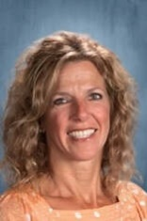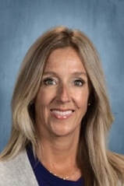
Remember….
Use Schoology to check assignments & class info
& Powerschool to check grades & attendance.

Let’s Make it a GREAT YEAR CHIPPEWA!!
Mrs. Frohock, Dr. Lawrence & Mrs. Wall

